Performance Testing
Amount of Data Loaded:
"Amount of Data Loaded" refers to the quantity or volume of data that has been imported, retrieved, or loaded into a system, software application, database, or any other data storage or processing environment. It's a measure of how much data has been successfully processed and made available for analysis, manipulation, or use within the system.

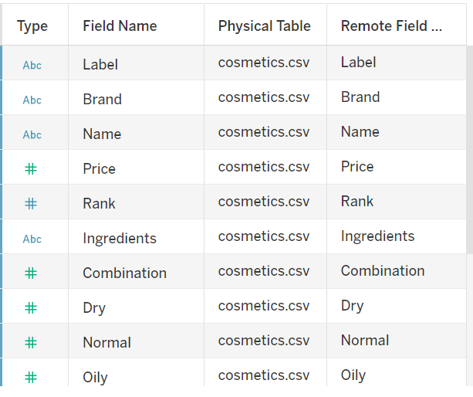
No.of Visualisations/ Graphs
- Top Brands
- Label Count
- Price vs Brand
- Sensitive skin suitability
- Normal skin suitability
- Oily skin suitability
- Dry skin suitability
- Brand vs Ranking
- Label vs Ranking

